* **INTRODUCTION:**

Python Programming

Artificial Intelligence

* **Python Programming:**
* Python is a powerful multi-purpose programming language created by Guido vanRossum.
* It has simple easy-to-use syntax, making it the perfect language for someone trying to learn computer programming for the first time.
* **Features:**

1. **A simple language which is easier to learn:**  
   Python has a very simple and elegant syntax. It's much easier to read and write Python programs compared to other languages like: C++, Java, C#. Python programming focus on the solution rather than syntax.
2. **Free and open-source:**  
   You can freely use and distribute Python, even for commercial use. Not only can you use and distribute softwares written in it, you can even make changes to the Python's source code.
3. **Portability:**  
   You can move Python programs from one platform to another, and run it without any changes.  
   It runs seamlessly on almost all platforms including Windows, Mac OS X and Linux.
4. **Extensible and Embeddable:**  
   Suppose an application requires high performance. You can easily combine pieces of C/C++ or other languages with Python code.  
   This will give your application high performance and scripting capabilities
5. **A high-level, interpreted language:**  
   Unlike C/C++, you don't have to worry about daunting tasks like memory management, garbage collection and so on.
6. **Large standard libraries to solve common tasks:**  
   Python has a number of standard libraries which makes life of a programmer much easier since you don't have to write all the code yourself. For example: Need to connect MySQL database on a Web server? You can use MySQLdb library using import MySQLdb .
7. **Object-oriented:**Everything in Python is an object. Object oriented programming (OOP) helps you solve a complex problem intuitively.  
   With OOP, you are able to divide these complex problems into smaller sets by creating objects.

**Reasons to choose python as a first language:**

\***Simple Elegant Syntax**

**\*Not overly strict**

**\*Expressiveness of the language**

**\*Great Community and Support**

* **ARTIFICIAL INTELLIGENCE:**

**Artificial Intelligence is the branch of computer sciences that emphasizes the development of intelligence machines, thinking and working like humans.**

* Speech recognition
* Learning
* Planning
* Problem solving

**Examples of AI:**

1.smart phones

2. Smart Cars and Drones

3. Social Media Feed

4. Music and Media Streaming Services

5. Video Games

6. Online Ads Network

7. Navigation and Travel

* **Algorithm:**

The most important part of AI is the algorithm. These are math formulas and/or programming commands that inform a regular non-intelligent computer on how to solve problems with artificial intelligence. Algorithms are rules that teach computers how to figure things out on their own. It may be a nerdy construct of numbers and commands, but what algorithms lack in sex appeal they more than make up for in usefulness.

**Applications:**

### Integrated AI systems:

* [AIBO](https://en.m.wikipedia.org/wiki/AIBO) – Sony's robot dog. It integrates vision, hearing and motor skills.
* [Asimo](https://en.m.wikipedia.org/wiki/Asimo) (2000 to present) – humanoid robot developed by Honda, capable of walking, running, negotiating through pedestrian traffic, climbing and descending stairs, recognizing speech commands and the faces of specific individuals, among a growing set of capabilities.

## **Goals of AI:**

* **To Create Expert Systems** − The systems which exhibit intelligent behavior, learn, demonstrate, explain, and advice its users.
* **To Implement Human Intelligence in Machines** − Creating systems that understand, think, learn, and behave like humans.

**Natural Language**

Natural Language Processing (NLP) refers to AI method of communicating with an intelligent systems using a natural language such as English.

Processing of Natural Language is required when you want an intelligent system like robot to perform as per your instructions, when you want to hear decision from a dialogue based clinical expert system, etc.

The field of NLP involves making computers to perform useful tasks with the natural languages humans use. The input and output of an NLP system can be −

* Speech
* Written Text
* **OBJECTIVE OF THE PROJECT:**

Objective of the project is going to deal about predicting Breast Cancer Classification describes the prediction of Breast cancer stages in a person.

The main objective task is to make the correct prediction for a person who is effected by the Breast Cancer and also the stage of the disease.

Predicting the outcome of a disease using historical cases stored in datasets.

* **Problem Statement:**

Breast Cancer is one of the most common cancer in women, affecting about 10% of all women at some stages of their life, it is major problem in society.

* **Review of Literature:**

Literature review showed that there have been several studies on the several prediction problem using Statistical approaches and artificial neural networks.

The project contains a user interface where user can communicate with the system. User interface involves a form which need to be filled with the correct information of the patient.

The information of the patient involve the following factors:

**Attribute Information:**

* 1. ID number   
     2) Diagnosis (M = malignant, B = benign)   
     3-32)   
       
     Ten real-valued features are computed for each cell nucleus:   
       
     a) radius (mean of distances from center to points on the perimeter)   
     b) texture (standard deviation of gray-scale values)   
     c) perimeter   
     d) area   
     e) smoothness (local variation in radius lengths)   
     f) compactness (perimeter^2 / area - 1.0)   
     g) concavity (severity of concave portions of the contour)   
     h) concave points (number of concave portions of the contour)   
     i) symmetry   
     j) fractal dimension ("coastline approximation" - 1)

The predicted output can be displayed to the patient which says about status of the disease that having breast cancer or not. So, in the background prediction is done with the help of algorithms of Artificial Neural Network(ANN) by using binary classification.

* **Data Collection:**

The data is collected from the internet and the link as follows:

<https://tinyurl.com/bc-dataset>

The above dataset contains 33 columns in out of 33 it contains 30 independent variables that are the factors that lead to the disease and 1 dependent variable this is going to say whether thepatient is having Breast Cancer or not .

In the below links provides more information which is ueful for the project members

<https://www.cdc.gov/cancer/breast/basic_info/risk_factors.htm>

<https://www.nationalbreastcancer.org/causes-of-breast-cancer>

<https://www.mayoclinic.org/diseases-conditions/breast-cancer/symptoms-causes/syc-20352470>

The following links explains about risk factors, causes, sysmptoms and also provides the information

to get better understanding of data set which we are dealing in the project

It explains about the different types of cancer that occur and the causes and precautions to be taken for that particular type.

**Methodology:**

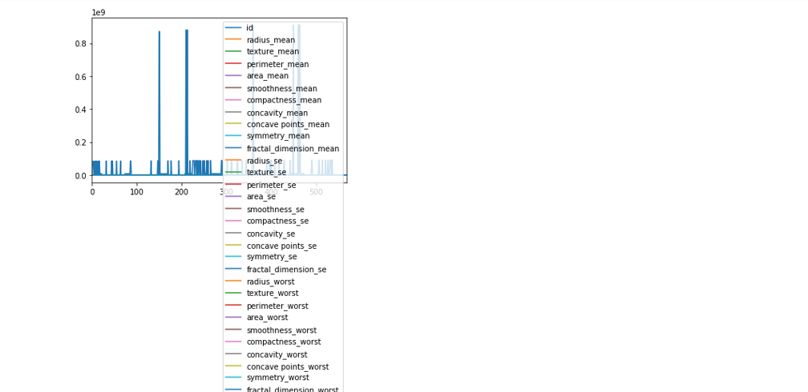

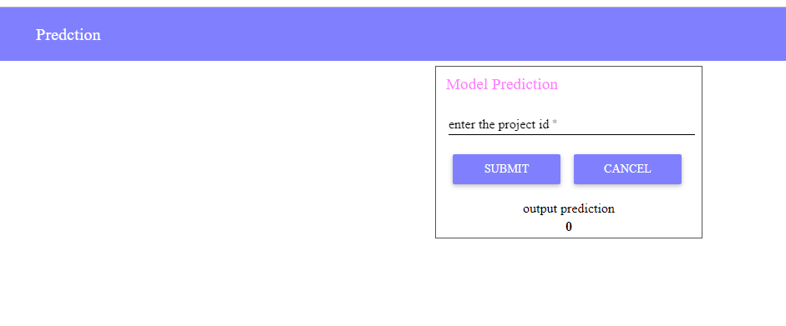

Cancer in begin stage is predicted.

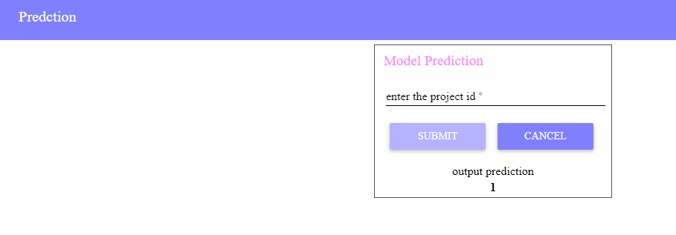

Cancer in malignant stage is predicted.

**DATA MODELLING:**

Classification algorithms are supervised machine learning algorithms. They are used to teach machines how to group data based on particular criteria. In today’s world of big data, classification algorithms help to make sense of data and find patterns. For supervised learning, data contains predictor variables and outcome. For classification, data set is divided into training and test samples. A predictor model is built using train data sample and tested for accuracy on test data sample.

Missing values in data have to be taken care of as they can lead to a biased model. Also we have to identify predictor, target variables. Also continuous, categorical variables have to be identified. For any classification algorithm, data has to be divided into train and test sets.

Confusion matrix which is cross-tabulation of actual and predicted status is used to calculate the accuracy of an algorithm. Also Sensitivity (true positive rate), Specificity (true negative rate) can be calculated and plotted as ROC curve to see the classifier ability.

**Findings and Suggestions:**

It contains information about various sources,updations and suggestions of the project.

The following are the links for more information about the project:

<https://www.itnonline.com/article/artificial-intelligence-helps-detect-breast-cancer-and-saves-time>

<https://www.radiologybusiness.com/topics/artificial-intelligence/google-ai-detecting-breast-cancer-put-test>

* **Conclusion:**

So we conclude thatArtificial Neural Network(ANN) with python programming played a vital role in the project.

Our project is successfully completed thedeployment of model and created a user interface with the help of Node-Redwhich is the development tool of the IBM Cloud and able to predict the Breast Cancer of the patient.